Keeping the Sanctuary Simple

A Brief OVERVIEW of the Sanctuary,
it’s Sections and Contents [furniture], their Functions,
and the Sanctuary’s Application to the life of Jesus Christ

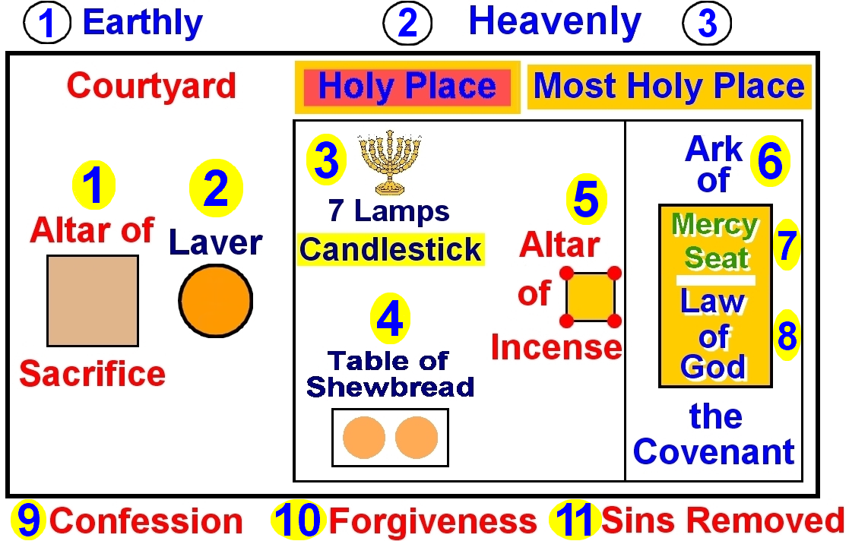

We will answer the following questions.
- What are the 3 sections of the Sanctuary?
- What are the contents [furniture] of each section?
- How does each section operate?
- What is the main function of each section?
- What is the application of Christ’s LIFE and MINISTRY to the Sanctuary?

1) The Sections of the Sanctuary

What are the 3 sections to the Sanctuary?
- Courtyard
- Holy Place
- Most Holy Place

2) The Contents [furniture] INSIDE EACH Section of the Sanctuary

What is in the Courtyard?
- Altar of Sacrifice
- Laver (Wash basin)

What is in the Holy Place?
- Candlestick (Lampstand)
- Table of Shewbread
- Altar of Incense

What is in the Most Holy Place?
Ark of the Covenant

What is INSIDE of the Ark of the Covenant?
- The 10 Commandments (Law of God) written by God’s own finger
- Aaron’s rod that budded (not shown)
- Golden pot of manna (not shown)

What is ON TOP of the Ark of the Covenant?
The Mercy Seat

What is ON TOP OF the Mercy Seat?
Two Angels, wings outspread, looking downward (not shown)

What was the Ark of the Covenant overlaid with?
Gold

What was in THE SIDE of the Ark of the Covenant?
The book of the law that Moses wrote (not shown) [Deuteronomy 31:24-26]

3) The Operation of EACH Section of the Sanctuary

1) What happened in the Courtyard?

Two basic things happened in the Courtyard.
- The MORNING and EVENING sacrifices for the whole nation of Israel
- The INDIVIDUAL PERSON’s offering

  - In EACH service a lamb was killed and the priest would take some blood from the lamb.

  - In the case of the INDIVIDUAL, the person would
- Bring a lamb into the Courtyard
- Put his/her hands on the head of the animal and confess their sins
- They would then take a knife and cut the throat of the animal.
- The priest would take some blood from the lamb.

2) What happened in the Holy Place?

The priest would take the lamb’s blood from the Courtyard into the Holy Place and offer it on the
Altar of Incense for the forgiveness of sins.

3) What happened in the Most Holy Place?

ONCE a YEAR, on the LAST DAY of the YEAR,
- The High Priest would go into the Most Holy Place and perform certain services including
sprinkling the blood of the slain “Lord’s” goat “upon the mercy seat, and before the mercy seat”. Leviticus 16:15
- AT THE END OF THE DAY,
- he would take all the sins of all the people who had confessed all their sins, and who had all their sins forgiven in the Holy Place, and
- put them on the head of the scapegoat.
- The scapegoat would then be taken out into an uninhabited area of the wilderness by the hands of a fit man, and left there.

4) The Main Function of EACH Section of the Sanctuary

- Courtyard – CONFESSION (by the nation, individual) 

- Holy Place – FORGIVENESS (by God, through Jesus Christ) 

- Most Holy Place – BLOTTING OUT (REMOVAL) of ALL CONFESSED and FORGIVEN SINS from 

the Most Holy Place in the Sanctuary. The only sins that were blotted out (removed) were the sins of all those who had confessed all their sins and who had all their sins forgiven in the Holy Place.

5) The Application of Christ’s LIFE and MINISTRY to EACH Section of the Sanctuary

Area and Ministry Time Periods ¹

- Courtyard – Jesus LIFE, DEATH, RESURRECTION 4 BC – 31 AD
- Holy Place – Jesus Christ’s ministry in the HEAVENLY Sanctuary 31 AD – 1844
- Most Holy Place – Jesus Christ’s ministry in the HEAVENLY Sanctuary 1844 – Close of Probation

¹ The 1st time period is well established by all Christians through the Messianic prophecies in the Old Testament and their
fulfillment in the New Testament. The 2nd and 3rd time periods can be shown in the light of the 2,300 day prophecy of Daniel 8:14 and the day for a week principle of Ezekiel 4:6. Included in the time frame of the 2,300 day prophecy of Daniel, 8:14 is the prophecy of Daniel 9:24-27. In it is the prophecy of Jesus dying in the midst of the week in verse 27, which establishes the start and the length of Christ’s public ministry in the 1st time period. This prophecy in Daniel 9 becomes a fundamental component of the 2,300 day prophecy. We are currently in the 3rd time period, near it’s close.

