Sanctuary-Cross
4
Study 1 – Introduction and Color Code
Hour 2-2
Test Your Memory

CTR

1.20

1.37

8.02

11.34

14.37

15.32

15.37

15.40

16.14

18.35

19.01

19.27

22.27

25.46

- What word does God use in Exodus 25:40 to identify what Moses was to copy in making the sanctuary? _______________
- Where is the ORIGINAL sanctuary located? ____ ______________
  - Is a BADGER in the Middle East a land or sea animal? _______________
- What metal was the laver in the courtyard made out of? ________________
- What is plaiting of the hair? _________________
- Looking at the Sanctuary, was it’s beauty on it’s interior or it’s exterior? _____________
- Was the beauty of Christ from His interior or His exterior? _____________
- As Christ’s followers, where should our beauty be, interior or exterior? _____________
- What metal were the caps (chapiters) of the brass posts made of? __________

Start of Question and Answers Discussion at end of study
- Discussion of certain things coming.
              - The 12 tribes, their standards, and the priests.
              - The 4 curtains that covered the sanctuary.
- Closing Prayer

NOTE: Counter numbers above are for identifying an area on the video and are based on the WEB videos counter numbers of the Sanctuary Cross studies.

No Jesus Christ, No Salvation.
Know Jesus Christ, Have Eternal Life.

He that hath the Son hath life. 1 John 5:12

Sanctuary-Cross
4
Study 1 – Introduction and Color Code
Hour 2-2
Summary

CTR
1.20

1.37

8.02

11.34

14.37

15.32

15.37

15.40

16.14

18.35

19.01

19.27

22.27

25.46

- “And look that thou make them after their pattern, which was shewed thee in the mount.” Exodus 25:40
- In Heaven.
- A BADGER in the Middle East is an amphibious animal meaning they can live on either land
or in water. The word amphibious “Amphi- meaning "on both sides" and -bios meaning "life” –Wikipedia
- And he made the laver of brass, and the foot of it of brass, of the looking glasses of the women assembling…. Exodus 38:8
- Plaiting of the hair is braiding it with strands of hair. In Bible times among some women they
would put gold into their hair and braid (plait) it into their hair so that it sparkled in the sunshine.
- The Sanctuary’s beauty was in its golden interior.
- The beauty of Christ was in His interior.
- As Christ’s followers, our beauty will be in our interior, just like Christ’s interior?
- The caps (chapiters) of the posts were made of SILVER. (See Figure 1 below)
Start of Question and Answers Discussion at end of study.
      - Discussion of certain things coming.
        - The 12 tribes, their standards, and the priests.
  - The 4 curtains that covered the sanctuary.
2. Closing Prayer.
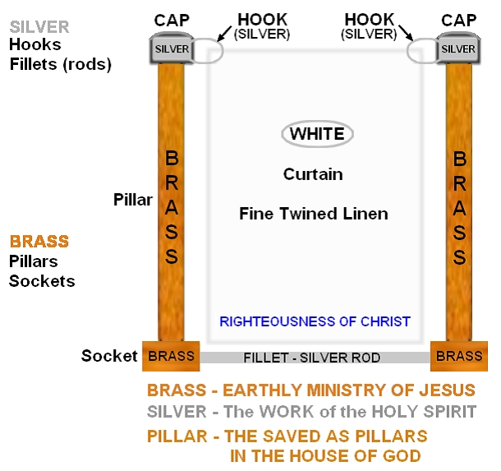

NOTE: Counter numbers above are for identifying an area on the video and are based on the WEB videos counter numbers of the Sanctuary Cross studies.
Figure 1
No Jesus Christ, No Salvation.
Know Jesus Christ, Have Eternal Life.

He that hath the Son hath life. 1 John 5:12

