Sanctuary-Cross
8
Study 2 – Overview of the Sanctuary
Hour 2-2
Test Your Memory

CTR

0.16

0.16

0.36

0.47

3.03

3.03
3.98

4.23

5.53

6.25

6.44

6.58

8.14

11.41

14.16

14.36

14.55

15.03

15.57

17.17

18.36

19.01

19.35

- Who are constantly interceding in man’s behalf? _______, _____ _________, and ___ _____ _______
- What is the difference between these 2? __________________________________________________
- Who works on our hearts, drawing out prayers, penitence, praise, and thanksgiving? ____ _____ _____
- What flows from our lips as a result of Who (?) striking the cords of our soul in holy memories…?
- We must pray in __________’s name and by the inspiration of ______ __________ __________.
- What prayers does God delight to answer? _______________________ _______________________
- Look at the diagram below and see how our prayers and their answers actually take place.
When we want to reach God, who do our prayers go through? _________ ____________
Who does God use when He wants to reach us? _____ _________ _______________
- What does the incense ascending with the prayers represent? ______ and ____________ ___ _______
- Smoke represents what? our ________________
- Before the veil of the Most Holy Place (in the Holy Place) is what kind of an altar? _________ ________
- Are our sins forgiven in the Most Holy Place or the Holy Place? ________________ Why?_________
- Did the blood of the lamb ever go into the Most Holy Place? ____ Where was it always offered? _____
- What is the office of Christ’s work? _____________________________________________________
- What happened in the first apartment (Holy Place) of the Sanctuary for 1,800 years? _______________
- You are pardoned by the ____________ blood in the __________ _____________.
- Blood takes care of the _____. What takes care of you as a sinner? ____ _____ __ ______ __________
- When you are pardoned, how does God view you? ____________________________
- When you are pardoned, what happens to your sins? _____________________________________
- When are you sins removed from the sanctuary? ___________ Where are they taken? ____________
- Where are our sins BLOTTED OUT? ____ ______ _________ _________ ______________
- The work of the Holy Place is to provide ___________ for our sins with the ________ blood of Christ.
- Christ Jesus is represented as ____________ _____________ at the __________ (in the Holy Place).
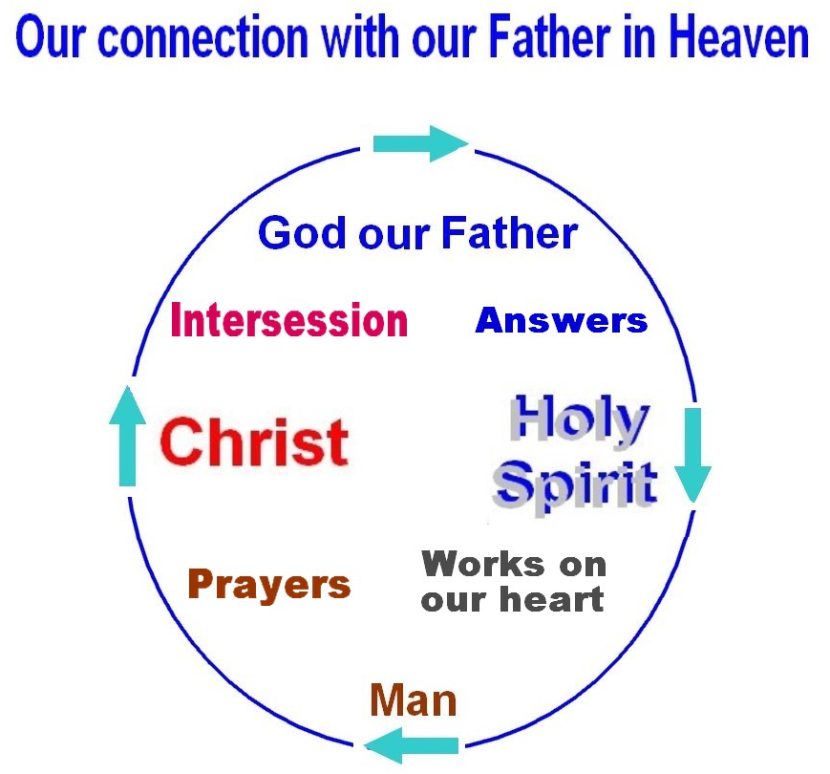

Question 7

NOTE: Counter numbers above are for identifying an area on the video and are based on the WEB videos counter numbers of the Sanctuary Cross studies.
No Jesus Christ, No Salvation.
Know Jesus Christ, Have Eternal Life.

He that hath the Son hath life. 1 John 5:12

Sanctuary-Cross
8
Study 2 – Overview of the Sanctuary
Hour 2-2
Summary

CTR

0.16

0.16

0.36

0.47

3.03

3.03
3.98

4.23

5.53

6.25

6.44

6.58

8.14

11.41

14.16

14.36

14.55

15.03

15.57

17.17

18.36

19.01

19.35

- Christ, our Mediator and the Holy Spirit.
- Christ presents His blood to the Father. The Holy Spirit didn’t die, so His intercession is different.
- The Holy Spirit
- “The gratitude which flows from our lips is the result of the Spirit’s striking the cords of the soul in
holy memories, awakening the music of the heart.” 1 Selected Messages, page 344.1
- “We must not only pray in Christ’s name, but by the inspiration of the Holy Spirit.”
Christ’s Object Lessons, page 147.3
- God delights to answer the prayers when we “pray in Christ's name“ and ” by the inspiration
of the Holy Spirit.” Christ’s Object Lessons, page 147.3
- The process by which our prayers are taken to God, answered, and then received are
  - Our prayers go to God through Jesus Christ as our heavenly-human Mediator.
  - Answers are returned from God through the Holy Spirit who works on our heart.
  - The incense, ascending with the prayers of Israel, represents the merits and intercession of Christ.
Patriarchs and Prophets, page 353.2
  - Smoke represents our prayers.
  - “Before the veil of the most holy place was an altar of perpetual [continuous, unceasing] intercession…”
Patriarchs and Prophets, page 353.2
- Our sins are forgiven in the Holy Place at the Altar of Incense. Since the Altar of Incense in the Holy
Place is an altar of PERPETUAL intercession, then, even though Jesus Christ is in the Most Holy Place,
the work of the forgiveness of our sins still continues from the Holy Place.
- No. The blood of the lamb was for the forgiveness of sins. It was always offered at the Altar of Incense
in the Holy Place.
- “As our Intercessor, Christ's office work is to introduce us to God as His sons and daughters.” 8T 177.2
- “For eighteen centuries this work of ministration continued in the first apartment of the sanctuary.
the blood of Christ, pleaded in behalf of penitent believers…’ Great Controversy, page 421.1
  - You are pardoned by the PLEADED blood in the HOLY Place in the Heavenly Sanctuary.
  - The blood takes care of the sin. The robe of Christ’s righteousness takes care of you as a sinner.
  - When you are pardoned God views you as perfect.
  - When you are pardoned your sins remains on the books of record.
  - Your sins remain on the books of record until they are transferred onto Satan, and Satan and your sins
end up in the Sea of FIRE at the end of the 1,000 years. This is WHEN our sins are cast into the sea.
- Our sins are blotted out in the Most Holy Place.
- The work of the Holy Place is to provide PARDON for our sins with the PLEADED blood of Christ.
- “Christ Jesus is represented as CONTINUALLY STANDING at the altar…” (Altar of Incense in the Holy Place).
NOTE: Counter numbers above are for identifying an area on the video and are based on the WEB videos counter numbers of the Sanctuary Cross studies.
No Jesus Christ, No Salvation.
Know Jesus Christ, Have Eternal Life.

He that hath the Son hath life. 1 John 5:12

